**In-Class Social Media**

"Don't raise your hand! Just like!"   
An in-class social medium where students can anonymously raise questions without having to interrupt the class. Questions are shown in a question box on individual computer screens and can be liked by other students, whose color changes as the number of likes increases. Java was used.

Execution Window - Students

SIGN IN

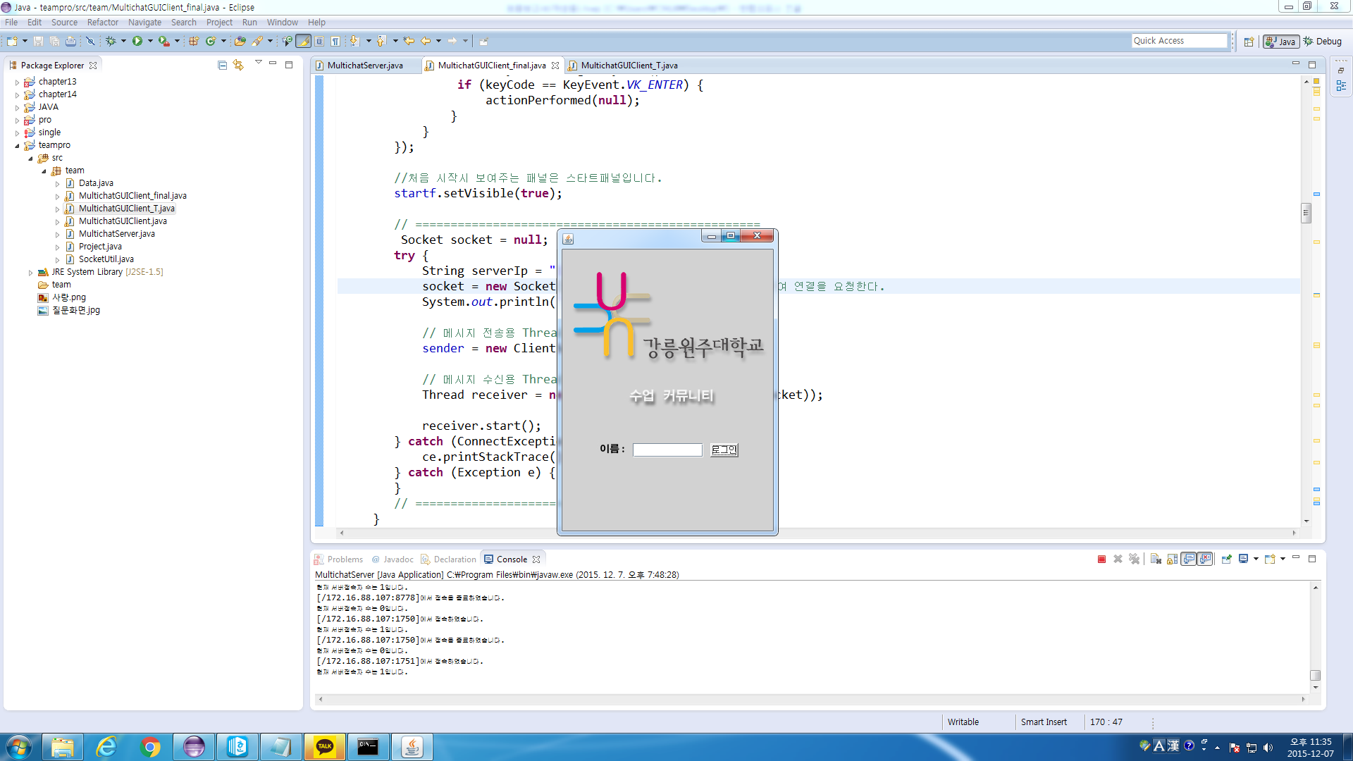

In-Class Social Media

Name

Sign In

Gangneung-Wonju National University

DEFALT FIELDS EXAMPLE

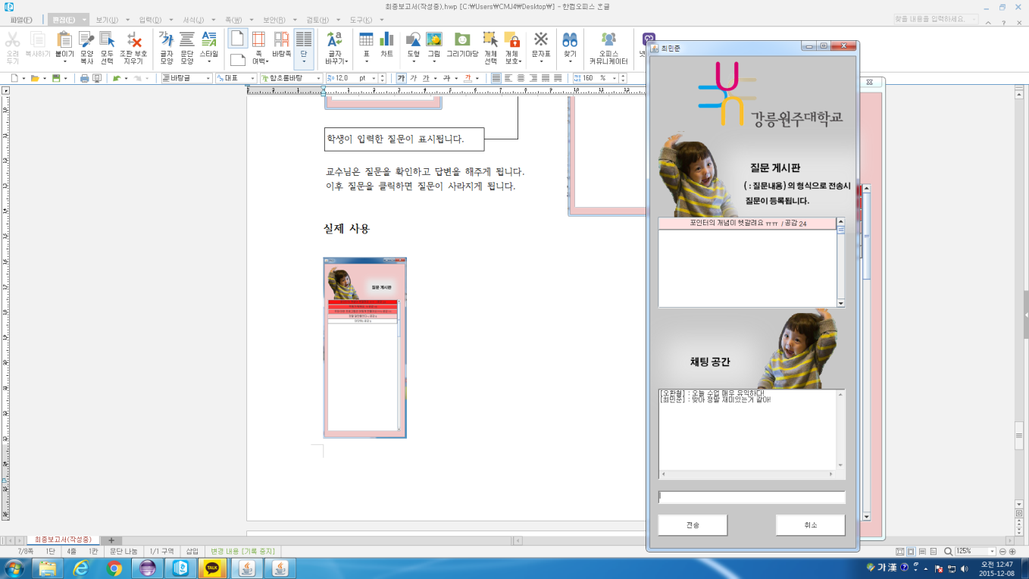

Questions appear in different colors based on likes by other students.

*Question* / Likes #

[Username] : *Message*

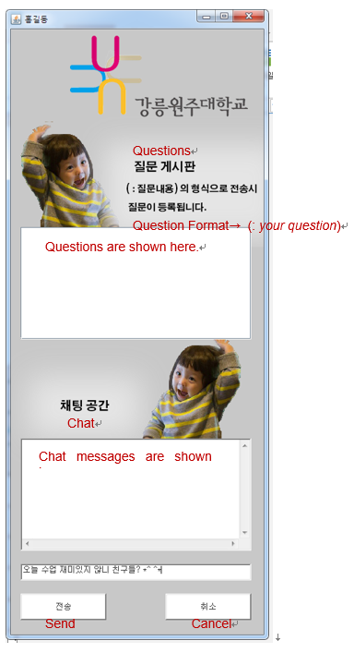

Chat

Execution Window – Professors

*Question boxes disappear when the professor clicks them.*

*Students’ chats are not displayed in professor’s execution window.*

